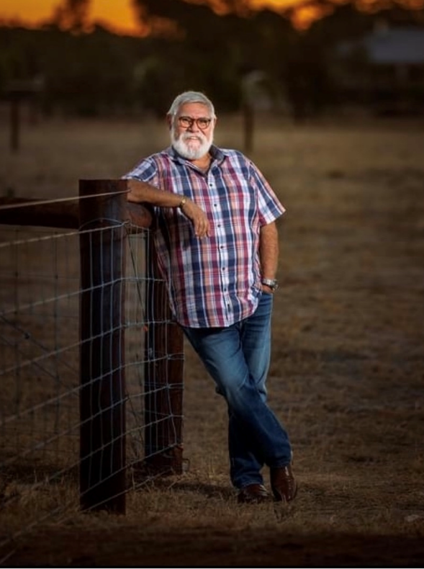

Alex Houthuysen (Hill). Alex is a proud Aboriginal man from the Yamatji Nation of the Pilbara region of Western Australia, having served his country as a member of the Defence Force (RAAF) and retiring after 21 years dedicated service, Alex continued to utilise his knowledge within the Airline Industry for a further 15 years working with National Jet Systems, Cobham Aviation and Surveillance Australia as the Survival Systems Engineer.
Seeking to find his identity Alex resigned from an Industry he loved and sought to enrich the life of myself and his growing family and began a lifelong journey of discovering my cultural identity, as a Stolen Generations survivor
Alex has previously worked in NGOs such as Career Employment Group as an employment consultant and continuing onto a similar role at Tauondi Aboriginal College as an employment Consultant and Mentor.
Alex is currently working within St Johns Youth Service Senior Management as the Aboriginal Culture Broker and supporting our First Nations clientele within the social services sector. Supporting Aboriginal & Torres Strait Islander young people to break the cycle of homelessness to move to a place they can call home, a transition to independence and to reconnect with community.
He currently is Deputy Chair of Port Adelaide Enfield Council Aboriginal Advisory Panel and an active board member of Turkindi Aboriginal & Torres Strait information service.
Alex also retains a position as an active board member of the Aboriginal Veterans SA and has a continuing interest in promoting the rights and importance in recognition of Aboriginal and Torres Strait Islander service men and women of shared service and the sacrifice of all Australians. Alex also holds board positions with Aged Rights Advocacy Service (ARAS) and is Deputy Chair of Aboriginal Family Support Services

